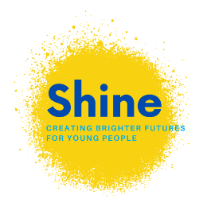
Self-Referral Form
Please return completed form to email: shine@sjmt.org.uk or send a clear photograph via WhatsApp to 07795245727
This information will remain confidential.
Shine is a service for young people. If you're care experienced, a care leaver or interested in education, employment and training opportunities then Shine maybe able to help.
Let us know if you need a hand filling in the form. You can contact us on 07795245727 or at shine@sjmt.org.uk

Young Persons Details
Your preferred pronouns:
Your full name
Date of Birth:
Address where you are currently staying (including postcode)
How would you like us to get in touch with you? | Mobile
 | Email address
 | Other
What sort of help are you looking for?
Is there anything else you feel ready to share with us now?

Someone from Shine will be in touch with you soon.

